 |  | LANDSAR INCIDENT REGISTER
Type of incident: | Injury (inc. fatality) |  |  | Property damage |  | No physical loss (near miss)
Person reporting incident: |  |  |  |  |  |  | Date of incident:
Your role at the time of the incident: |  |  |  |  |  |  | Time of incident:
Your email, LandSAR ID and contact number: |  |  |  |  |  |  | Date reported:
Brief description of the activity, location and the role of any affected/injured persons:
Person in control: |  |  |  |  |  |  | Tasking number:
Briefly describe what happened and the immediate treatment/emergency response:

Injured Person Details (if more than one person injured, complete separate forms for each)
Name of injured person: | LandSAR ID number:
Address: | Sex and date of birth:
Email and phone number: | Start time:

Record the nature of the injury ( as appropriate)
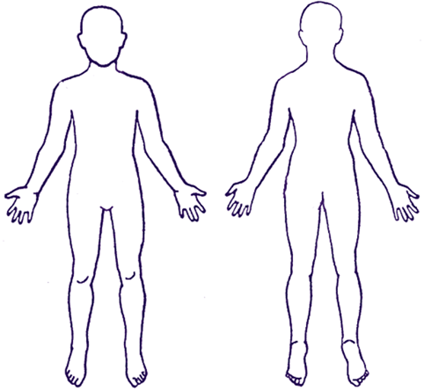  Front  Back |  | Injury details |  | Consequence of injury
 |  |  | Unknown |  | Unknown
 |  |  | Bruising |  | Seriously harmed
 |  |  | Crushing |  | Unable to continue
 |  |  | Cut |  | Continue restricted duties
 |  |  | Fracture |  | Medical treatment
 |  |  | Sprain/Strain |  | First aid
 |  |  | Graze |  | No treatment required
 |  |  | Eye injury | Consequence details:
 |  |  | Poisoning
 |  |  | Burn
 |  |  | Amputation
 |  |  | Hypothermia
 |  |  | Other (give details):
 | LANDSAR INCIDENT REGISTER
Initial Investigation (to be completed by Team Leader or person in charge)
Provide more detail on what happened:
List the names of the people involved:
What hazards were involved and what was being done to guard against them?:
What do you think the main causes of this accident/incident were?:
What could be done to reduce the chances of something similar happening in future?:

Corrective Actions
Detail the action to be taken to recover from this incident and to prevent a recurrence:
List any additional training, equipment or other resources required:
Person(s) responsible for any corrective actions:
When should they be completed by:

Signed by:
Team Leader/Person in control: |  | Date:
For LandSAR NZ: |  | Date:

PLEASE SEND THIS COMPLETED FORM TO: safety@landsar.org.nz

